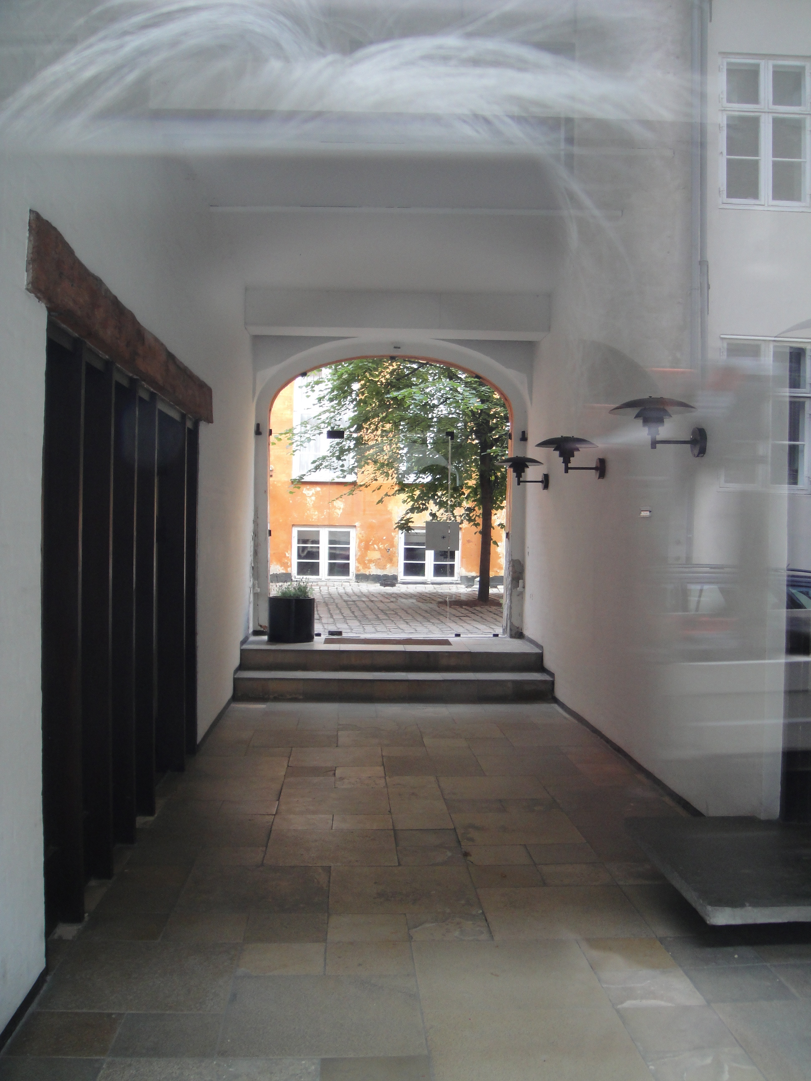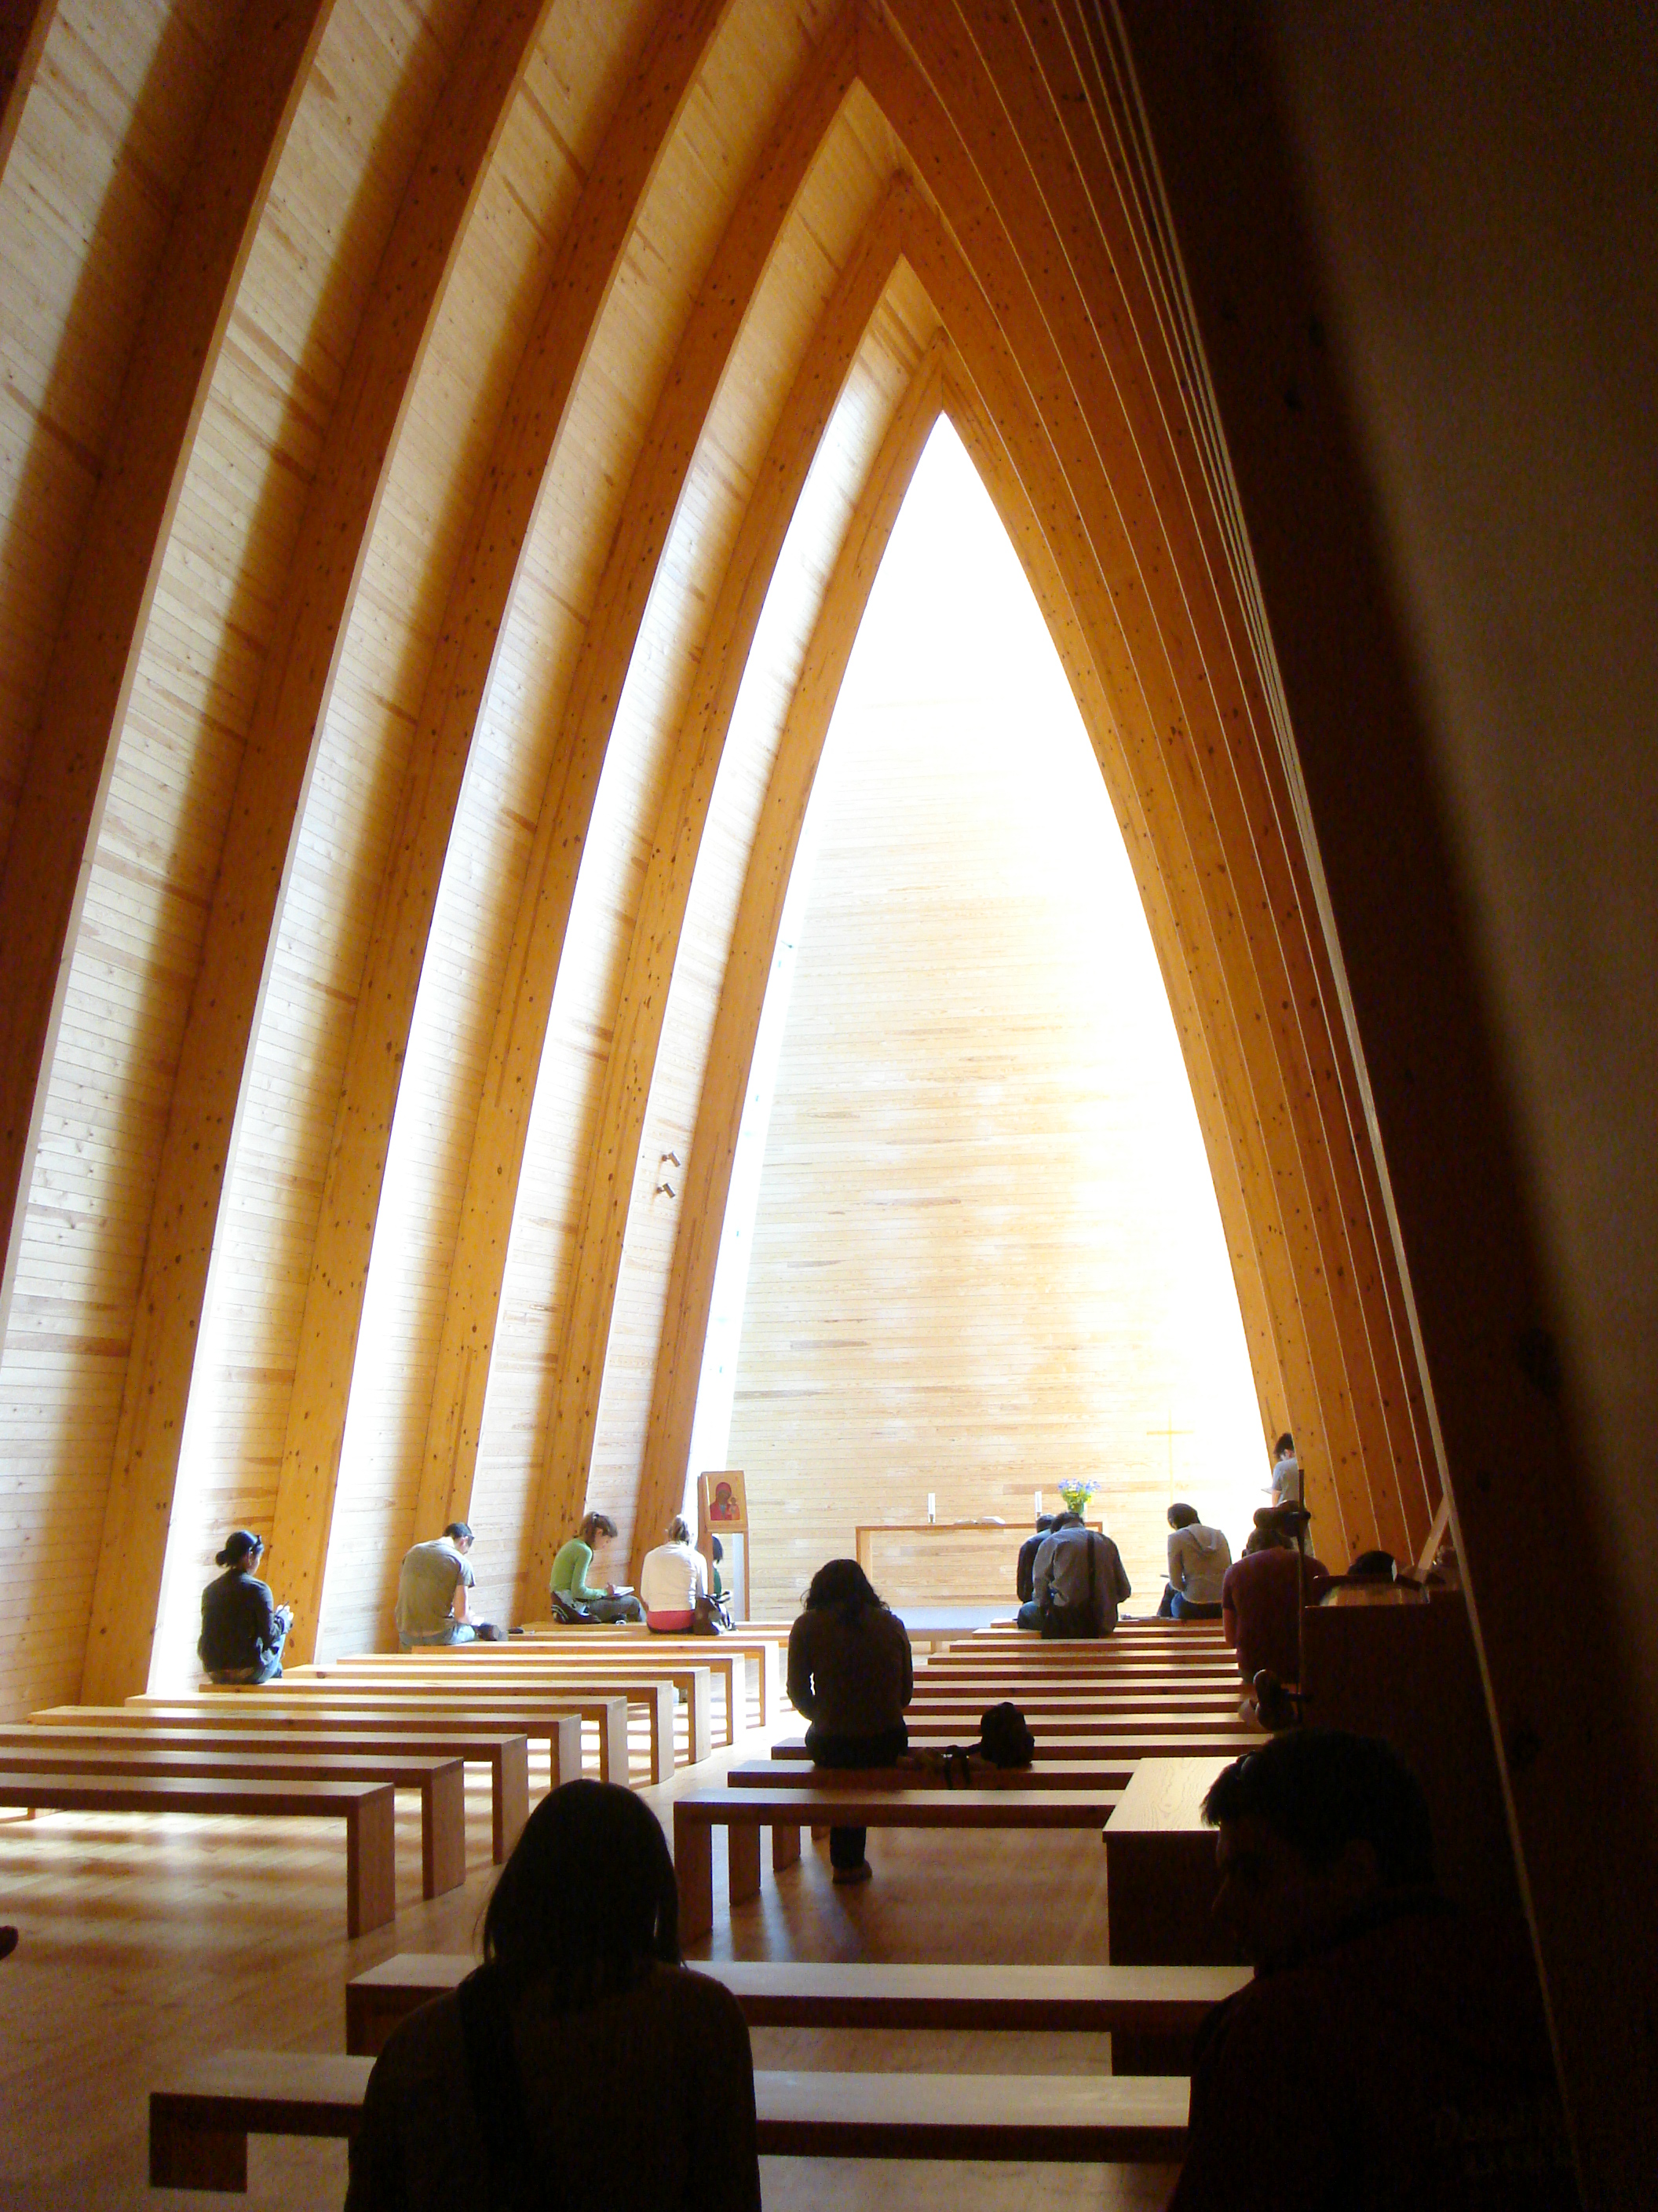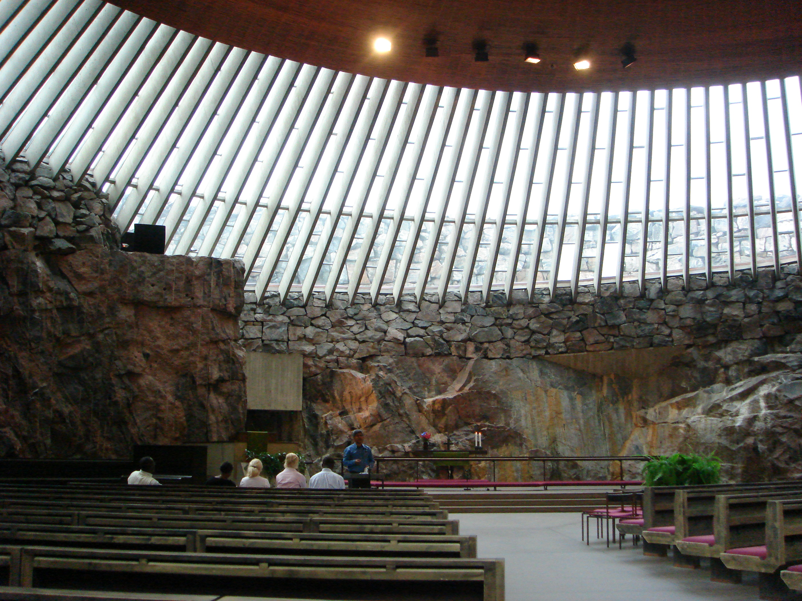

We are pleased to announce that the Pratt Copenhagen Summer Program will be offered in Summer 2018. More information can be found on the website of the Denmark International Study Program (DIS), www.dis.dk. Summer Program. You may also direct questions to the DIS Coordinator, Prof. Myonggi Sul. msul@pratt.edu

Qualification and Registration
This program is offered to students of all disciplines who have minimum of one year of studio work in their chosen field. Enrollment will be on a first come first serve basis. Danish Study Abroad Program assumes that if a student is in good standing at Pratt, he/she will be successful while participating in the Danish Study Abroad Program in Copenhagen.

Students interested in participating in the Summer Copenhagen Program should submit a completed Application form including the non refundable deposit of $500 by the application due date below in hard copy.

Additional information about registration, initial deposit, timelines, etc. will be forthcoming.

Pratt students have an option of participating in a three week lecture course during Session 1 & 2, summer program for 3 credits(Undergraduates only), four week lecture course during Session 4 for 4 credits(Undergraduates only) or a seven week architecture and design program during the late summer program for 7 credits(open to all architecture and design students).

Summer Program Session 1 & 2: 3weeks/3credits
3 weeks/3credits

https://disabroad.org/summer/build-your-summer/summer-course-finder/?session=session-1
https://disabroad.org/summer/build-your-summer/summer-course-finder/?session=session-2

Summer Program Session 3: 4 weeks, 4 credits

https://disabroad.org/summer/build-your-summer/summer-course-finder/?session=session-3

The courses offered in Sessions 1, 2, and 3 are generally courses that meet Liberal Arts requirements, although there are a few that meet Studio Elective requirement. Please contact msul@pratt.edu for more detailed information.

Summer Program Session 4: 7 week/7credits: Architecture and Design Session (Session 4)

https://disabroad.org/summer/build-your-summer/summer-course-finder/?session=session-4-architecture-design

Courses and Credits:

Design Studio is the backbone of the seven week Architecture and Design Summer Program in Copenhagen. Student will enroll in the studio of his/her choice from the options listed below for 3 credits, seminar course for 3 credits and a journal course for 1 credit for total of 7 credits. The following options for area of study are available for the Summer Program. Each Department Chairs have determined how the credits may apply, but in most cases, the seven credits are applied toward required studio elective credits for Graduate students, and 4 credits applied to studio electives and 3 credits applied to required Social Science credits for Undergraduates. The studio options are:

Architecture Design Studio & Visual Journal + 1 wk Nordic Study Tour
Furniture Design Studio & Visual Journal +1 wk Nordic Study Tour
Graphic Design & Visual Journal + 1 wk Nordic Study Tour
Interior Architecture & Visual Journal + 1wk Nordic Study Tour
Urban Design Studio & Visual Journal + 1 wk Nordic Study Tour

Architecture
Studio instruction focuses on the design process in Danish practice. Design problems address context, the user, and sustainability, starting from a critical analysis of Scandinavian architecture. Through a series of assignments, students develop their skills in conceptual design, representation, model-making, and communication. Studio groups combine students of different standing and background. The course is taught vertically, and expectations relate to each individual student.
Furniture Design
Studio instruction is a combination of one-on-one tutoring and discussions in studio and in the workshop. The studios are organized as vertical studios, meaning that students of different levels will be taught within the same studio. Expectations will therefore relate to each individual student and their respective experience.

Graphic Design
Studio focuses on urban graphic design. Design skills are developed through analysis of composition and function of existing signage and through urban signage design problems solved within the Danish context. Students work in digital and analog modes, advancing their communication skills and learning the opportunities and challenges of different media and user perception. Studio groups combine students of different standing and background. The course is taught vertically, and expectations relate to each individual student.
Interior Architecture
Studio focuses on Interior Architecture design in a Danish context, developing a concept and project design within an existing structure. Students create a design strategy shaping interior space and user experience. Through a series of assignments, students develop their skills in conceptual design, representation, model-making, and communication. Studio groups combine students of different standing and background. The course is taught vertically, and expectations relate to each individual student.
Urban Design
Using Copenhagen as a laboratory, students solve real-life problems using analytical and design methods integral to the field of urban design and landscape. Some sections in Urban Design Studio will focus on issues of sustainability. Through a series of assignments, students develop their skills in conceptual design, representation, model-making, and communication. Studio groups combine students of different standing and background. The course is taught vertically, and expectations relate to each individual student.
Study Tours and Field Studies:

A critical component of the Copenhagen Summer Program at DIS is the study tours.
“DIS places strong emphasis on combining classroom work with experiential learning so that you come away with applicable, real life, cross-cultural skills for the global job market. “
A week long study tour to Sweden and Finland or Sweden and Norway is part of the studio experience.

Financial Aid Application

Financial Aid is available for the DIS Summer Program Session 4 in Copenhagen. You should go to Financial Aid as soon as possible to fill out an application form even if you are not 100% certain that you will go on the study abroad program.

Calendar and Fees:

Application Calendar:

February 15 FAFSA Application/Financial Aid Application
March 15 Deadline for Application with receipt for $500 deposit
April 26 Deadline for total payment

Program Calendar:

Early Summer Program Session 1: May 21 to June 9
For Interior Design Students only

Sat. May 20 Latest departure from US
Sun. May 21 Arrival day
Mon. May 22 First day of classes
Sat. June 8 Last day of DIS Housing

Summer Program Session 2: June 11-June 30

Sun. June 10 Last Departure fro US
Mon. June 11 Arrival Day
Sat. June 16-Sun. June 24 Program-Integrated Study Tour
Sat. June 30 Last day of DIS Housing

Summer Program Session 3: July 2 to July 29

Sun. July 3 Latest departure from US
Mon. July 4 Arrival day
Mon. July 17-Fri. July 21 Program-Integrated Study Tour
Sat. July 29 Last day of DIS Housing

Architecture and Design Session, Session 4: July 11-July 29

Sun. June 10 Latest departure from US
Mon. June 11 Arrival in Copenhagen, introduction to housing
Wed. June 13 Start of Program
Sat. June 24-Sun. July 02 Program-Integrated Study Tours
Sat, July 29 Last day of DIS Housing

Costs

Short Summer 1 &2 session for 3 credits_3 weeks: Interior Design only

Graduate Tuition, 3 credits: $5,139
Undergraduate Tuition, 3 credits: $4,644
Study-Abroad Fee: $400
International Student Fee: $75

Paid Directly to DIS:

DIS Housing: Session 1: $1,450, Session 2: $1475
DIS Independent Housing Fee: $200

Short Summer Session 3 for 4 credits_4 weeks:

Graduate Tuition, 4 credits: $6,852
Undergraduate Tuition, 4 credits: $6,192
Study-Abroad Fee $400
International Student Fee: $75

Paid Directly to DIS:

DIS Housing: $1,775
DIS Independent Housing Fee: $240

Long Architecture and Design Session 4 for 7 credits_7 weeks:

Graduate Tuition, 7 credits: $11,991
Undergraduate Tuition, 7 credits: $10,836
Study-Abroad Fee: $400
International Student Fee: $75

Paid Directly to DIS:

DIS Housing: 7 weeks $2,925
DIS Independent Housing Fee, Arch & Des.: $400
Cost for transporting work back to NYC: TBD (Approximately $300)

Additional Expenses
Airfare $1000 - $1,500
Estimated personal expense $2,000 -$3,000

Airfare, books, studio supplies, and meals are the student’s responsibility.

Refund Policy – Cancellation

If you withdraw on May 10 or before, 100% of the total program cost will be refunded, except the non-refundable deposit of $500
If you withdraw May 17-23, 55% of the total program cost will be refunded, except the non-refundable deposit of $500.
If you withdraw on May 23 or after, no refund will be issued.

Housing

DIS guarantees housing to all students who request (and have paid for) DIS arranged
housing. The deadline for requesting summer housing is one month before the arrival date, but the sooner you sign up for housing the better. During the summer, Kollegium and DIS Residential Communities are the two housing options. However, if these two housing options reach capacity, students may be offered a Danish Roommate or a Host Family. Once you’ve been admitted to DIS and are registering online for your summer abroad, you will have an opportunity to express interest in one of these alternative options. More information can be found on the website, www.dis.dk.

DIS Residential Community
The DIS Residential Community option, you live with other DIS students in a DIS housing facility. The facilities are all relatively centrally located and furnished. The sizes vary and two or more students often share a room. You will either share a kitchenette and a bathroom with your roommates or share a common kitchen and bathroom with fellow DIS students living in the same building.
Kollegium
Kollegium is the Danish word for a student residence hall. European universities usually do not have campuses; consequently, Kollegiums are used by students from various universities and colleges. The Kollegiums have been divided into three categories.
Traditional Kollegiums: Live in a kollegium where there is a possibility for social events and informal get togethers with other residents. You share the kitchen with 10-12 other residents and will typically have your own room and bathroom, or a double room that you share with another DIS student.
International Kollegiums: Boost your study experience with an international influence and choose to live in kollegiums with international students. In this independent apartment style setting, you will usually share a bathroom and common facilities with one or two students, or be in a facility where you share only the kitchen with three other students
Independent apartment-style Kollegiums: Choose to lead an independent lifestyle and live in one of DIS’ independent apartment-style kollegiums. You will have your own room, bathroom and kitchenette. These kollegiums generally do not offer social activities as there are typically no common facilities.
Independent Housing
Students arrange for his/her own housing. Independent Housing Fee applies. Students who switch between DIS Housing to Independent Housing after May 1 will be subject to a $100 change fee plus any additional direct costs.
Scholarship:
DIS offers a scholarship to students in the Summer Program on need basis. Please request a scholarship application form from the DIS Coordinator, Myonggi Sul by emailing: msul@pratt.edu
DIS also awards two/three merit scholarships presented at Pratt during the Fall DIS exhibit.
Visa Requirements:
Citizens of the U.S., Canada, Australia and the European Union do NOT need a Danish Residence permit or tourist visa to study in Denmark for the summer. You simply arrive with your passport, which must be valid 3 months beyond the last day of stay in the Schengen countries.
If you are NOT a citizen of the U.S., Canada, Australia, or the European Union, you MAY need a tourist visa to enter Denmark. A list of countries whose citizens need a visa to enter in Denmark can be found on the Immigration Service’s web site: http://www.nyidanmark.dk/en-us/coming_to_dk/visa/need_visa/who_needs_visa.htm
For the DIS Study Tours: Students who are NOT citizens of the U.S., Canada, Australia, or the EU may need to apply for additional tourist visas for the academic study tours. DIS will assist students with applying for visas once the students have begun the get started packet for the Summer Study Abroad Program.
The tourist visa will allow you to enter all Schengen countries: Austria, Belgium, the Czech Republic, Denmark, Estonia, Finland, France, Germany, Greece, Hungary, Iceland, Italy, Latvia, Lithuania, Luxembourg, Malta, The Netherlands, Norway, Poland, Portugal, Slovakia, Slovenia, Spain, Sweden and Switzerland. You have to apply for the Schengen visa at the Embassy/Consulate of your main destination.
Royal Danish Consulate
885 Second Avenue, 18th floor (48th Street)
New York, NY 10017-22-1
212.223.4545
If you are required to obtain a tourist visa, you will need to:
*Register your application online through the Visa Self Service Denmark website: http://www.gknewyork.um.dk/en/menu/PassportVisa/TouristBusinessTransitVisa/
Upon registration and payment of the visa fee, you may either schedule a personal appointment at the Consulate General in New York to submit the required documents, or mail the required documents to the Consulate General.
*A passport with a validity that exceeds the intended stay in Schengen by at least three months. Other travel documents by at least six months. Passports must have been issued within the last ten years. Please make sure that your passport/travel documents has a blank page to affix the visa.
*One recent Passport photo. No hats, scarves, sunglasses etc.
*A valid U.S. Resident Alien Card(copies or notarized copies are not acceptable) or a valid U.S. visa (including the I-94 or I-94W form). Students should present a valid I-20. If returning to the U.S., the residence permit/visa must be valid at least three months beyond the last day of the intended stay in Denmark/Schengen.
*Proof establishing the purpose of your trip. Once you’ve submitted your Get Started registration form, the DIS North American Office will provide you with this letter. Please contact Steve Olson at: olsonsc@umn.edu with questions regarding a visa to Schengen countries, and Mia Schleifer: mschleif@pratt.edu at the Pratt International Affairs Office with questions regarding return to U.S.
*A recent bank statement or international credit card statement in your name. You need to show that you have $50 per day while you are in the Schengen area($25 per day if you are staying with family, friends, or DIS provided housing). If you are unable to submit bank or credit card statement, you can submit copies of traveler’s checks.
*Proof of travel insurance. DIS will provide a letter from the insurance company directly to the Danish Consulate General on your behalf.
*Proof of accommodation. Once you’ve submitted your Get Started registration form, the DIS North American Office will provide you with this letter. Please contact Kari Theil at: ktheil@umn.edu with questions.
*Proof that you can continue your trip after your visit to the Schengen countries, i.e. confirmed itinerary from airline or travel agent. On approval of your Schengen visa your original airline ticket must be submitted. E-tickets showing ticket number and payment in full is acceptable.
*If you cannot pick up your passport once the visa has been issued, the passport will be sent to your home or business address-at your own risk- via Federal Express. In this case, an additional $20 will be charged. Do NOT include a PO Box mailing address on your appication, FedEx cannot deliver to PO Boxes and the return of your passport will be delayed.
*You may only send CASH or MONEY ORDERS made out to the Danish Consulate. No personal checks. You should check the current visa fees on the Consular website.
Processing time:
Most applications will be processed by the Roayl Danish Consulate General, and may take up to 2 months. In some cases, the application must be referred to the Danish Immigration Service in Denmark and may take longer.

The following is the credit distribution for the summer session 4 by DIS studio and Pratt major, determined by your home department at Pratt for each department. All other session credit distribution is elective credits.
Industrial Design Students:
Undergraduate students taking Furniture Design Studio: IND401BK1(R)-3 credits, ART491-1 credit, SS483(R)-3 credits,
Undergraduate students taking any other design studio: SS483(R)-3 credits, ART493 3 credits, ART491-1credit.
Graduate students taking Furniture Design Studio: IND628K1(R) 3 credits, ART693 3 credits, ART691 1 credit.
Graduate students taking any other design studio: ART696-6credits, ART691-1 credit.
All Other Department Students:
Undergraduate students: SS483(R)-3credits ART463-3 credits, ART461-1 credit,
Graduate students: ART696-6 credits, ART691-1 credit.

- ART denotes Studio Elective credits.
- (R) denotes credits taken at DIS which count toward required courses at Pratt Institute.

